**ideation phase**

**brainstorm & idea prioritization**

|  |  |
| --- | --- |
| Date | 19 September 2022 |
| Team ID | PNT2022TMID43271 |
| Project Name | Ideation phase brainstorm & idea prioritization |
| Maximum Marks | 4 Marks |

**Introduction**

These efforts have enabled India, which started off low, to become the second fastest digital adopter among 17 major digital economies. Several factors have contributed towards this achievement – one governance and digital identity, the growth and penetration of mobile internet access, e-commerce, digital payments, and the rise of digital media among online consumers.

**Brainstorm & idea prioritization**

Brainstorming provides a free and open environment that encourages everyone within a team to participate in the creative thinking process that leads o problem solving. Prioritizing volume over value, out-of-the-box ideas are welcome and built upon, and all p Developed and developing countries across the globe are coming out with white papers and national strategies on AI. Many of these strategies involve developing ethics and principle-based guidelines for use of AI, and identifying changes needed to existing laws and regulations, in addition to formulating new ones to enable its use. Prominent examples of among these countries are the United Kingdom, China, the United States of America and Singapore.

In addition to formulating guidelines for effective use of AI across industries, nations across the world are trying to develop comprehensive regulation for AI to address associated ethical, legal, social and economic issues.

**Step-1: India: Government initiatives to harness AI**

Expressing its intent to invest in AI, the Indian government, in its 2018 Union Budget, doubled its past allocation to the Digital India initiative (USD 480 million or Rs 3,703 core) for the growth of digital technologies. The Government’s commitment includes extensive investment in research, training, and skill development in areas such as AI, big data intelligence, robotics, digital manufacturing, and quantum communications. 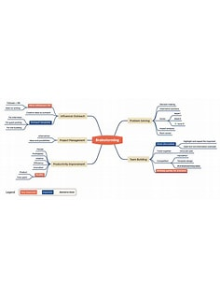

**Step-2: Zero Credit Touch strategies**

The Bank was trying to develop “Zero Credit Touch” (ZCT) strategies where without any credit intervention and additional information taken from customers, credit facilities can be provided. Following challenges are faced in the creation of ZCT strategies using traditional credit underwriting models.

1. Credit models which are combination of business rules and scorecards do not qualify a significant proportion of existing ICICI Bank customers.

2. Wherever customers do not have a salary account with the Bank, estimated income is lower leading to customer being offered an amount lower that his/her requirement .

**Step-3: Idea Prioritization**

The banking sector in India is now increasingly adopting AI. According to a joint research conducted by the National Business Research Institute and Narrative Science, about 32% of financial service providers in India are already using AI technologies such as predictive analytics and voice recognition.

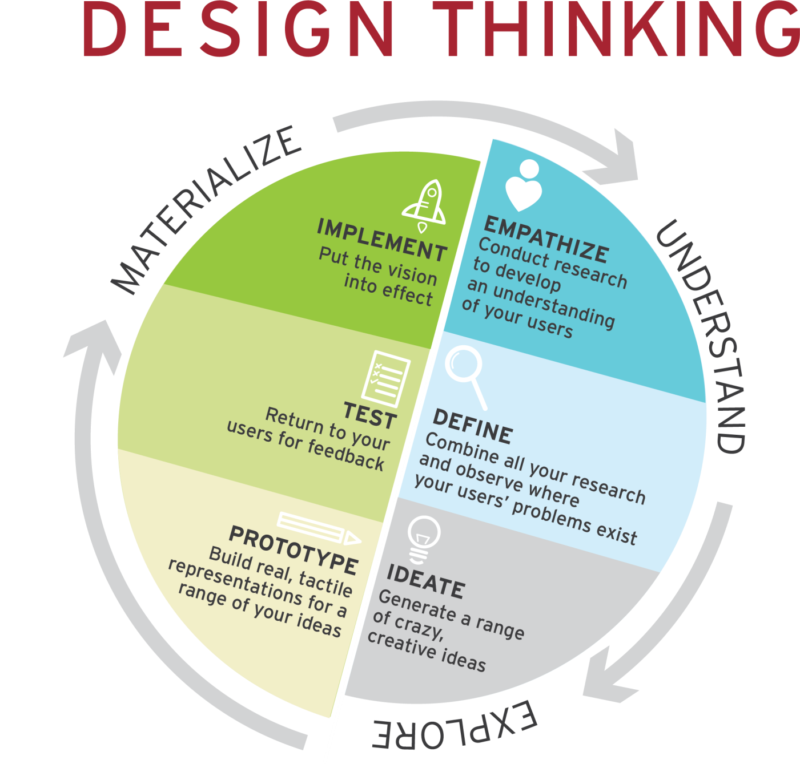

**Develop Use cases in dev virtual assistants for banks**

**Challenge**: A financial services group in South Africa that offers wholesale and retail banking services was looking to grow revenue in mass affluent customer segment with conversational commerce but without increasing the number of human agents.

**Solution**:

The bank, in collaboration with Microsoft developed a digital assistant to service affluent customers. The digital assistant is deployed with LUIS and Microsoft Azure Framework, a comprehensive framework for developing enterprise-grade conversational AI experiences. .

The resultant benefits were an estimated 90% savings in transactional costs and improved efficiency without increasing the number of actual persons involved.